|  |  |  |  |  |  |  |  |  |  |  |  |  |  |  |  |  |  |
| --- | --- | --- | --- | --- | --- | --- | --- | --- | --- | --- | --- | --- | --- | --- | --- | --- | --- |
|  | ICHAQ AHMED gsqs3D | | | | | | | | | | | | | | | | |
|  | L C- C UR E | | | | | | | | | | | | |  | | | |
|  |  | | | | | | | | | | | | | | | | |
|  |  | | | | | | | | | | | | | | | | |
|  |  |  | | | | | | | | | | | | | |  | cl |
|  | as Al,ere C)Vev | | | | | | | | | | | | | | | |
|  |  | |  | | | | | | | | | | | | | | |
|  |  |  | | | | | | | | | | | | | | | |
|  |  | |  | | | | | | | | | | | | | | |
|  |  | | | | | | | | | | | | | | | | |
|  |  | | | | | | | | | | | | | | | | |
|  |  | | | | | | | | | | | | | | | | |
|  |  | | | | | | | | | | | | | | | | |
|  | QOM | | | | | | | | | | | | | | | | |
|  |  | | | |  | | | | | | | | | | | | |
|  |  | | | | | | | | | | | | | | | | |
|  |  | | |  | | | | | | | | | | | |  | |
|  |  | | | | | | | | | | | | | | |  | |
|  |  | | | | | | | | |  | | | | | | | |
|  |  | | | | |  | |  |  |  | |  |  | |  |  | |
|  |  | | |  | |  | |  | |  | |
|  | | |  | |  | |  | |  | |  |  | |
|  |  | | |  | |  | |  | |
|  |  | | | | | | | | |  | | | | | | | |
|  |  | | | | | | | | | | | | | | | | |
|  |  | | | | | | | | | | | | | | | | |
|  | 8heÝ¿ | | | | | | | | | |  | | | | | | |
|  |  | | | | | | | | | | | | | | | | |
|  | VS owe | | | | | | | | | | | | | | | | |
|  |  | | | | | |  | | | | | | | | | hab | |
|  |  | | |  | | | | | | | | | | | | | |
|  |  | | | | | | | | | | | | | | | | |
|  |  | | | | | | | | | | | | | | | | |



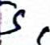

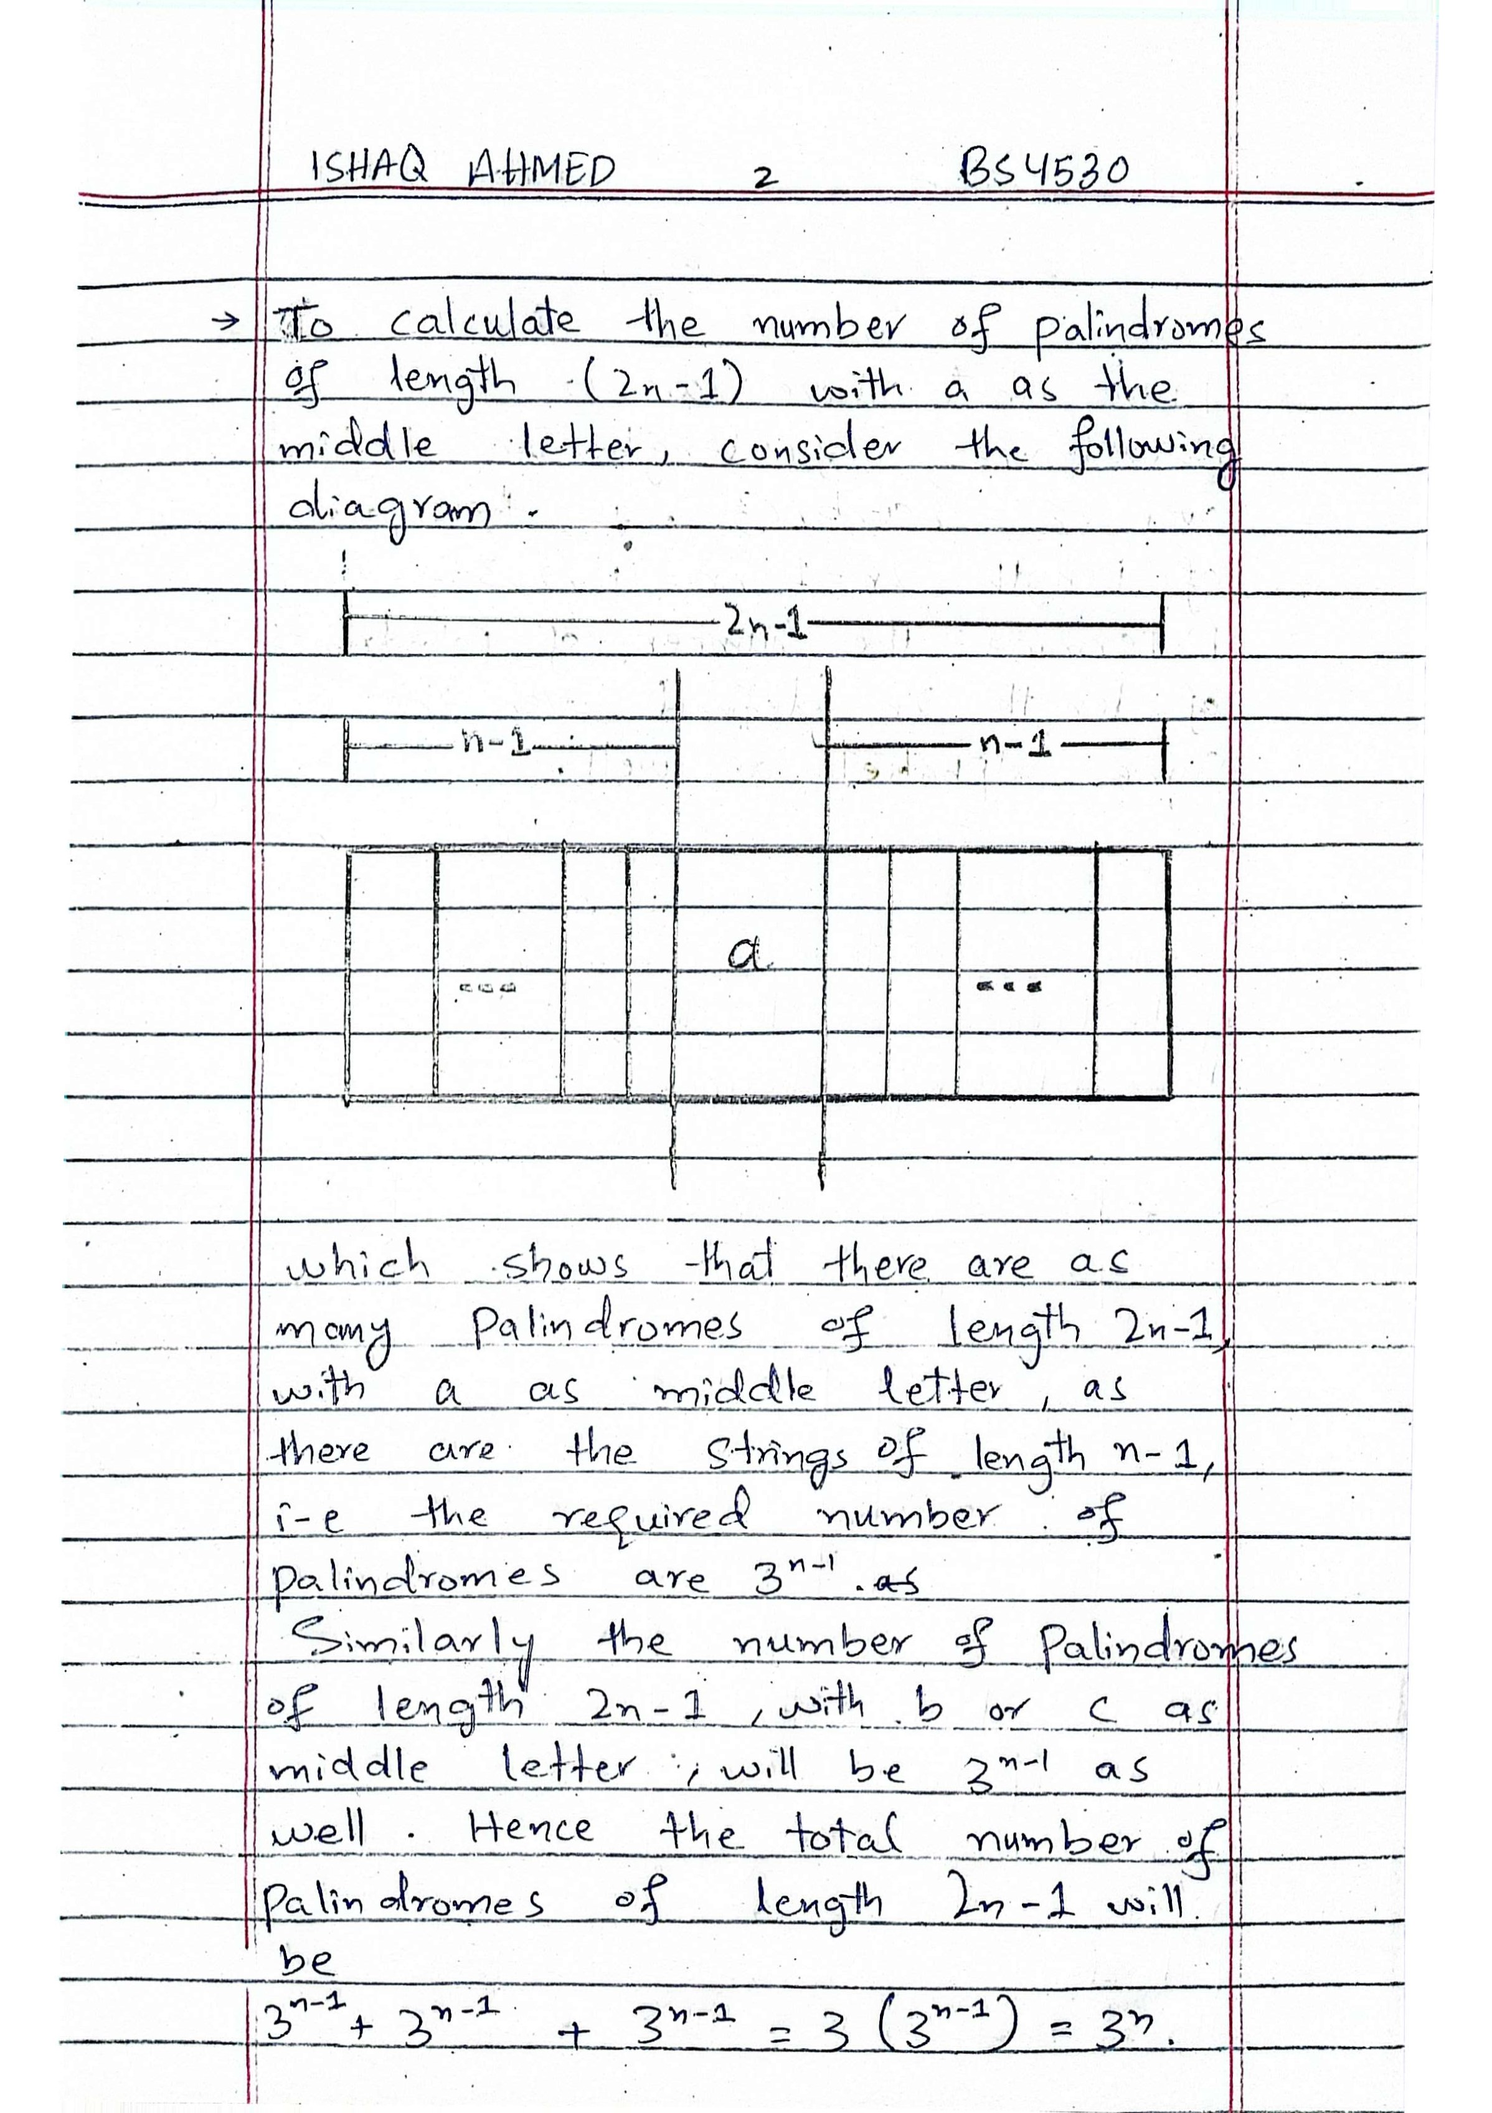

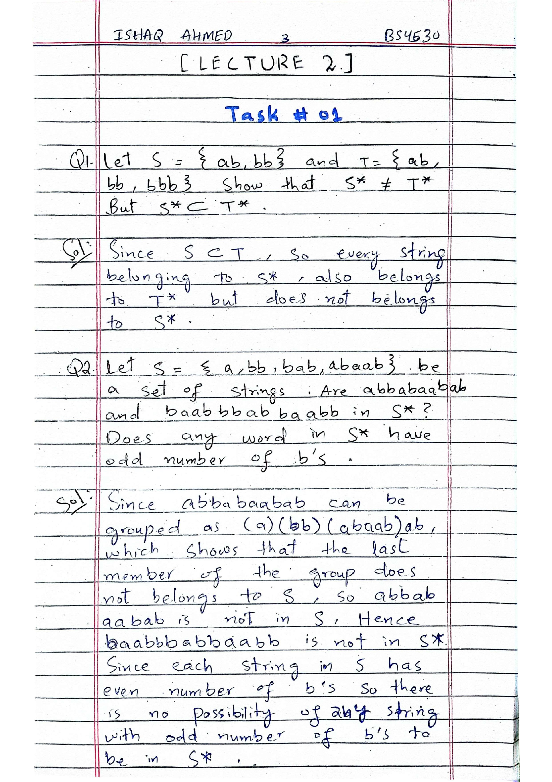

|  |  |  |  |  |  |  |
| --- | --- | --- | --- | --- | --- | --- |
|  | 区材合Q  M  Cs | | | | | |
|  | 0 | | | | | |
|  |  | | | | | |
| し | 区身い 叺 Ca レ6 Ⅵ | | | | | |
|  |  | | | | a物ゝwe | |
|  |  | | | | | |
| So | ス Sヮ /\ / ↓レ宅 | | | | | |
|  | △ ど | | | | | |
|  | (も/色れみS十クしを | | | | | |
|  | 私从 A山ちg± | | | | | |
|  | 1 4圦ゝ弌 | | | | | |
|  |  | | | | | |
|  | v色日 | | |  |  | |
|  | S . | | | | | |
|  |  | | | | | |
|  |  | | | | | |
|  | を ぞⅥ (く0 | | | | | |
|  | いレ:にれ日。らぞは | | | | | |
|  | 乙らあ気員 ハ内; 0ら、均 | | | | | |
|  | oも  voら長一-(5米    叺 弍S* | | | | | |
|  | 号け | | | | |
| ー《M乙 | | | | | |
|  |  | | | | | |
| (の | S + )ヤ | | | | | |
|  |  | | | | | |
|  | 1 (  0 Ⅵ (久色&ー ぃしに | | | | | |
|  | 計れキ久t ~1し 0吼巳 | | | | |  |
|  | し c-o Ⅵ。斗'、れ レれ 0・ | | | | | |
|  | eゼ久・e | | | | | |
|  | 5い邑5ギ和几 4从計 し之 | | | | | |
|  | 。气,れら | |  | | | |
|  |  | | | | | |

